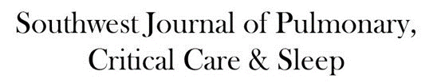

Journal of the Arizona, New Mexico, Colorado and California Thoracic Societies www.swjpcc.com
December 2023 Pulmonary Case of the Month: A Budding Pneumonia

Ishan A. Patel, MD¹
Sarah K. Medrek, MD¹
Michael D. Reyes, MD²
Brannon L. Raney, MD³
Section of ¹Pulmonary, Critical Care, and Sleep Medicine, ²Pathology, and ³Infectious Disease
VA Albuquerque Health System
Albuquerque, NM USA

History of Present Illness
A 70-year-old man with a history of seropositive rheumatoid arthritis previously well controlled on hydroxychloroquine, methotrexate, and adalimumab was admitted to the hospital with 3 weeks of progressively worsening fatigue, night sweats, chills, and malaise. He did not describe new or worsening cough, shortness of breath, or sputum production. On the day of admission, he had intense nausea and vomiting.
PMH, SH, and FH
Prior to this admission, he was followed in Pulmonary Clinic for asymptomatic mild basilar fibrosis thought to be related to his rheumatoid arthritis and paraseptal emphysema related to prior smoking which was largely stable and unchanged over the previous two years. Previously, he smoked cigarettes at ½ pack per day for about 30 years and quit about 15 years ago. He denied any recent travel and was retired from the last 15 years from being a meat butcher. FH is noncontributory.
Physical Examination
On examination the day after admission from the ER, the patient’s temperature was 37.6C. His pulse was 79 bpm, blood pressure was 142/65 mmHg, and pulse oximetry revealed a saturation of 92% with 2 LPM nasal cannula of O2. He appeared generally weak, but alert. Pulmonary exam was unrevealing as was cardiac exam. He did not have cyanosis, clubbing, delayed capillary refill, or peripheral edema.
Laboratory
Initial blood work showed a WBC count of 7500/µL, hemoglobin level of 9.6 gm/dl, serum blood urea nitrogen of 36 gm/dl, serum creatinine of 2.49 g/dl, and serum calcium that was elevated at 12.3 mg/dl. A T-spot was obtained and was negative. Blood and sputum cultures were obtained and negative.
Radiography
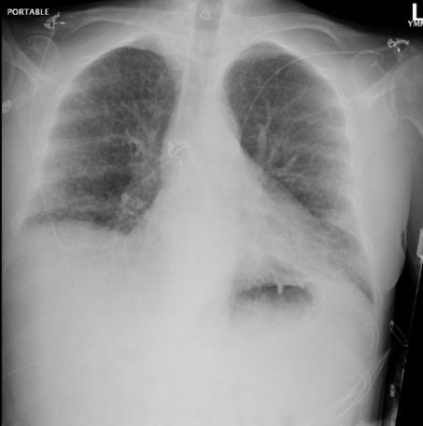
Figure 1. Admission portable chest x-ray in the emergency department. To view Figure 1 in an enlarged, separate window click here.
The patient has a history of rheumatoid arthritis (RA). Which of the following patterns of interstitial lung disease (ILD) is most common in patients with RA?
- Acute eosinophilic pneumonia
- Lymphocytic interstitial pneumonitis
- Non-specific interstitial pneumonia
- Organizing pneumonitis
- Usual interstitial pneumonitis

Correct!
5. Usual interstitial pneumonitis –UIP
Rheumatoid arthritis (RA) is one of the most common autoimmune conditions worldwide. CT abnormalities of the lungs can occur in 50-70% of patients. The disease can affect the lung parenchyma, airways, or pleura. Occasionally, airway involvement of RA may be the first manifestation of systemic RA. Clinically significant ILD related to RA (RA-ILD) can happen in up to 10% of RA patients. The most common ILD pattern found in patients with RA-ILD is UIP – usual interstitial pneumonitis - characterized by basal predominate architectural distortion with reticulation, traction bronchiectasis, and honeycombing. Other pulmonary manifestations that can be seen in RA include airways disease which can be characterized by bronchiectasis, constrictive bronchiolitis, as well as follicular bronchiolitis. Occasionally, necrobiotic nodules can be found that can mimic lung cancer with pathology on biopsy showing fibrinoid necrosis and granulomatous inflammation which can regress with therapy.
Our patient has a history of RA-ILD in a UIP pattern as well as paraseptal emphysema from a history of smoking who was followed closely in pulmonary clinic (Figure 2) now presenting with a new, subacute illness.
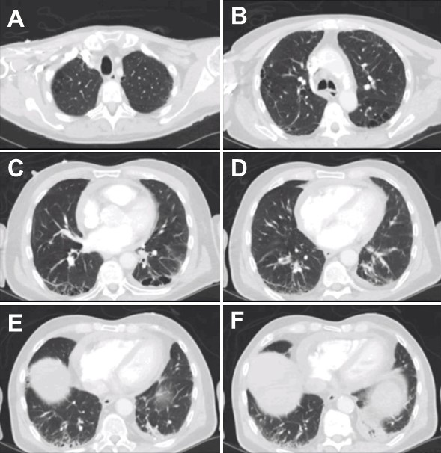
Figure 2. CT scan of the patient’s chest approximately 6 months prior to admission while being followed in Pulmonary Clinic for asymptomatic basilar-predominate fibrosis secondary to RA-ILD and paraseptal emphysema. To view Figure 2 in a separate, enlarged window click here. To view a video of the CT scan click here.

Which of the following diagnostic tests should be completed on admission?
- CT chest, abdomen, pelvis
- Blood cultures
- IV hydration
- 1 and 3
- All of the above

Correct!
5. All of the above
The patient appears to be ill but does not seem to show signs of septic physiology. While he is at high risk for volume depletion, his exam is not suggestive of intravascular hypovolemia. He also is demonstrating evidence of hypercalcemia of undetermined etiology, which would merit IV hydration. Given the history of immunosuppression, a thorough workup for infection should be undertaken, including obtaining blood cultures and more advanced imaging to include chest and abdomen given his previous known chest abnormalities and a history of recent nausea and vomiting.
A CT scan of the chest, abdomen, and pelvis was performed (Figure 3). 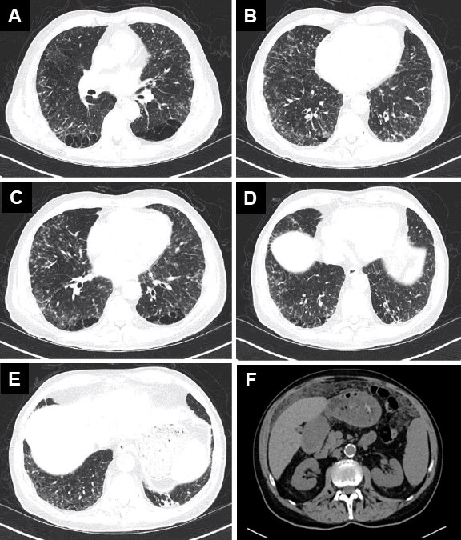
Figure 3. Representative images from admission CT chest (A-E) and abdomen (F). To view Figure 3 in a separate, enlarged window click here. To view a video of the CT scan click here.

CT scanning revealed new areas of bilateral diffuse tree-in-bud nodularity as well as an ill-defined extensive infiltration of omentum with thickening. There was no evidence of significant pleural effusion, lobar consolidation, or discrete lung mass.
What would be the next most appropriate step?
- Obtain cultures, antigenic, and serologic workup for infectious etiology.
- Begin corticosteroids for worsening ILD.
- Bronchoscopy with bronchoalveolar lavage and transbronchial biopsy
- 1 and 3
- All of the above

Correct!
4. 1 and 3
The patient is an immunocompromised patient presenting with non-specific and vague symptoms raising the possibility for underlying infection, particularly centered in his chest given his CT chest findings. It would be very reasonable to obtain serologic and culture data to help narrow the differential diagnosis as well as perform a bronchoscopy with bronchoalveolar lavage with transbronchial biopsy to obtain samples directly from the site of interest. Assuming worsening of RA ILD and treating with empiric corticosteroids is wrong because of the high risk for an infection.
Sputum, blood, and urine cultures were obtained which were negative. Serum beta 1,3 glucan and galactomannan were obtained and negative. A bronchoscopy was performed, and BAL was performed which was sent for cell count, bacterial, AFB, and fungal culture which showed a no significant growth of organism in 5 days of growth. A transbronchial biopsy was also performed at the time of bronchoscopy which showed non-caseating granulomas with stains negative for bacterial or fungal elements.
Which of the following should be the next step?
- Biopsy of the omental thickening
- Video-assisted thoracic surgery (VATS) lung biopsy
- Open lung biopsy
- Repeat bronchoscopy and transbronchial biopsy
- Discharge with careful follow-up in 6 weeks

Correct!
1. Biopsy of the omental thickening
Given the situation, pursuing a diagnosis is indicated. The omental biopsy is easiest although a VATS lung biopsy is reasonable. Repeating the bronchoscopy with transbronchial biopsy seems unlike to be diagnostic. Ultimately, the patient then underwent CT-guided biopsy of the omental thickening due to the ill-defined nature of the mass. Representative pathology slides are shown in Figure 4.

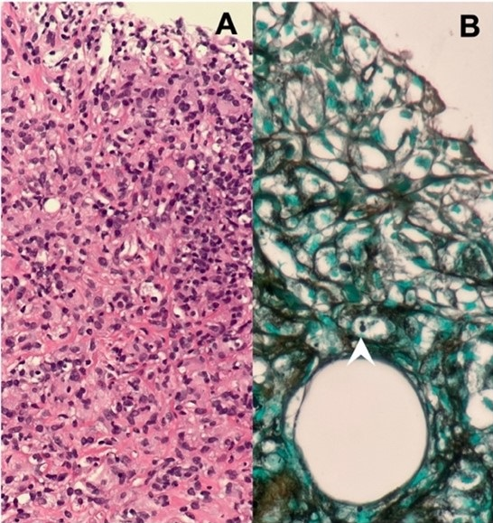
Figure 4. Representative slides from CT-guided biopsy of an ill-defined mass infiltrating the omentum in our patient revealed a chronic inflammatory infiltrate composed of lymphocytes and histiocytes on hematoxylin and eosin (H&E) stain (A, 20x magnification). Rare yeast are highlighted with a Grocott’s Methenamine Silver (GMS) stain, including occasional yeast with narrow based budding (B, arrow head, 40x magnification). To view Figure 4 in a separate, enlarged window click here.

Pathological analysis showed occasional small yeast with narrow based budding. Which of the following fungi could be most compatible with the above pathological analysis?
- Aspergillus
- Mucorales
- Candida
- Histoplasma
- Malassezia

Correct!
4. Histoplasma
Histoplasma is a dimorphic fungus that causes one of the most common respiratory fungal illnesses worldwide. Highly endemic regions in the United States include the Ohio and Mississippi river valleys and around the world including parts of South America, Central and Southern Africa, and Western Asia.
Respiratory symptoms develop after inhalation of Histoplasma and conversion from the ambient environmental mycelial form to the yeast-like form, which can take several hours to days. The differential for yeast organisms includes Blastomyces, Cryptococcus, and Coccidioses.
Severity of infection depends on the immune status of the individual, number of spores inhaled, and virulence of the particular strain. Most illnesses are self-limited and asymptomatic but it can progress to severe, life-threatening illness particularly in susceptible individuals. Symptomatic histoplasmosis typically presents as a flu-like illness with symptoms including fevers, chills, malaise, headache, myalgias, non-productive cough, and chest pain. A small proportion of patients can present with arthritis and arthralgias with characteristic erythema multiforme or erythema nodosum, as well as pericarditis, rarely. Mediastinal lymph nodal disease is common - ranging from mediastinal adenitis (early in disease) to mediastinal granuloma and fibrosing mediastinitis as two distinct, but late complications. Disseminated disease is more common in individuals with malignancy, immunosuppression, corticosteroid use, or HIV. Pathogenesis of disease in this sub-group of patients usually involves tempered cellular immune response from blunted T-cell number and or function secondary to either low CD4 counts (such as in HIV/AIDS), use of corticosteroids, calcineurin inhibitors, or TNF-blocking agents.
Gold standard for diagnosis is made with culture although growth can be slow (up to 1 month) or negative in up to 50% of respiratory cultures. Serology techniques that detect antibodies or antigen is available for rapid detection however, cross-reactivity exists between Histoplasma and other endemic fungal diseases.
The patient was started on therapy which included itraconazole. Over the next few weeks, he developed initially improved symptoms but then had worsening shortness of breath, orthopnea, and lower extremity edema. He then was readmitted to the hospital.

Which of the following diagnostic tests would be indicated to evaluate for a potentially rare, but serious side effect of itraconazole?
- Ventilation-Perfusion (V/Q) Scan
- Lower extremity doppler ultrasound
- Transthoracic echocardiogram
- Cardiac MRI
- Cardiac stress test

Correct!
3. Transthoracic Echocardiogram
A potentially rare, but serious side effect of itraconazole therapy is development of itraconazole-induced cardiotoxicity in the form of acute or acute-on-chronic congestive heart failure. The exact mechanism remains unclear however negative inotropy through mitochondrial dysfunction has been implicated in animal models. Multiple case reports have detailed this rare side effect that largely improves after cessation of drug therapy.
Our patient demonstrated a moderately reduced ejection that was new compared to 3 months prior. He underwent cardiac catheterization which ruled out ischemic heart disease. After careful review of his recent medical history, itraconazole was implicated as a cause of his new heart failure. He was stopped on this medication and switched to isavuconazole which has demonstrated in vitro activity in treating Histoplasma. Other azoles, including fluconazole, ketoconazole, posaconazole, and voriconazole all have some variable rates of efficacy against Histoplasma; however, none have been adequately studied in robust clinical trials. Second line therapy should be selected with the expert guidance of Infectious Disease specialist.
Clinical Pearls
- In patients who are immunocompromised – either due to medical history or from medications – having an aggressive infectious workup is recommended as manifestation of disease can be atypical
- Histoplasma can manifest in multiple organs and cause infiltrative disease
- First line treatment of histoplasma – itraconazole – is associated with acute congestive heart failure in a small population of patients
Patient Course
Our patient was identified as having acute disseminated histoplasma on basis of pathological review of his CT-guided biopsy of his omentum which showed rare yeast with narrow based budding. On further questioning, he identified that he had lived in the Ohio River Valley many years ago. Further, he had cleaned the roof of his house which was full of bird droppings approximately 2 years prior to presentation.
Additional workup and expert consultation were sought for his pathology slides which demonstrated PCR+ for histoplasma. A urine antigen for histoplasma came back elevated, eventually.
While undergoing first line treatment with itraconazole, he developed non-ischemic cardiomyopathy and congestive heart failure requiring change of medication to a second-line therapy, isavuconazole, under the expert guidance of Infectious Disease. He continued isavuconazole for a year and repeat CT chest showed complete resolution of his tree-in-bud opacities. His urinary histoplasma antigen has remained negative.

References
- Araúz AB, Papineni P. Histoplasmosis. Infect Dis Clin North Am. 2021 Jun;35(2):471-491. [CrossRef] [PubMed]
- Azar MM, Hage CA. Laboratory Diagnostics for Histoplasmosis. J Clin Microbiol. 2017 Jun;55(6):1612-1620. [CrossRef] [PubMed]
- Corte, T.J., Wells, A.U. “Connective Tissue Disease.” Murray & Nadel’s Textbook of Respiratory Medicine, 92, 1262-1283.e16.
- Hage CA, Azar MM, Bahr N, Loyd J, Wheat LJ. Histoplasmosis: Up-to-Date Evidence-Based Approach to Diagnosis and Management. Semin Respir Crit Care Med. 2015 Oct;36(5):729-45. [CrossRef] [PubMed]
- Wheat LJ, Freifeld AG, Kleiman MB, Baddley JW, McKinsey DS, Loyd JE, Kauffman CA; Infectious Diseases Society of America. Clinical practice guidelines for the management of patients with histoplasmosis: 2007 update by the Infectious Diseases Society of America. Clin Infect Dis. 2007 Oct 1;45(7):807-25. [CrossRef] [PubMed]

